Section 4.132. Town Center Zone.

(.01) Applicability and Purpose.
The Town Center (TC) Zone applies to lands within the Town Center Comprehensive Plan Map designation. The TC Zone is a Planned Development Zone, subject to applicable Planned Development regulations (see Section 4.140 and 4.118). Where conflicts occur between these standards and other Development Code regulations or other ordinances, the provisions of this Chapter shall apply.
The purposes of the TC Zone are to:
- Implement the Town Center policies and implementation measures of the Comprehensive Plan.
- Implement the Wilsonville Town Center Plan recommendations for the Town Center Comprehensive Plan Map designation.
- Create a vibrant, walkable destination that inspires people to socialize, shop, live, and work.
- Support future development that transforms Town Center into the heart of Wilsonville.
- Foster active parks, civic spaces, and amenities that provide year-round, compelling experiences.
- Create a development pattern where Wilsonville residents and visitors come for shopping, dining, culture, and entertainment.
Sub-districts. The TC Zone includes four sub-districts (Figure 1):
a. Main Street. A walkable and lively main street with a mix of active uses and three- to four-story buildings through the heart of Town Center along Parkway Avenue, which would extend south past Town Center Park to Wilsonville Road.
b. Neighborhood-Mixed Use. Development would be primarily small-scale mixed-use, two- to three-story development, with neighborhood-serving commercial businesses or townhomes adjacent to Town Center Loop East and the existing residential neighborhoods. Neighborhood-mixed use provides a transition from single-family neighborhoods east of Town Center Loop East to the central portions of Town Center.
c. Mixed Use. A variety of two- to four-story buildings throughout Town Center would provide the mix of residential, commercial and office uses the community is looking to have in Town Center. Moderate activity near Wilsonville Road would be commercially focused while the areas near Town Center Park would include more residential and mixed-use buildings.
d. Commercial-Mixed Use. Allowing taller buildings, up to five stories, along I-5 and near the future bike/pedestrian bridge landing, would improve Town Center’s visibility, help create a sense of place, and support the increased level of activity and economic vibrancy desired by community members, including additional employment opportunities, entertainment, and hospitality services. As proposed, residential uses in this area would be required to be buffered from I-5 by non-residential buildings.
If a development site includes more than one sub-district, and the development of different portions of the parcel under different sub-districts is not feasible due to site size or other site constraints not related to proposed uses, the applicant may follow the standards for either sub-district within 50 feet of the sub-district boundary. The selection and application of the sub-district standards must provide for compatibility with any existing or approved development designed pursuant to the TC Zone standards and result in building orientation consistent with the building and street frontage requirements in Subsection 4.132 (.06) B.

(.02) Uses permitted anywhere in the TC Zone
- Open space
- Multiple-family Dwelling Units, except in areas immediately adjacent to I-5 as noted in Subsection (.03) A. below within the Commercial-Mixed Use District.
- Public or private parks, playgrounds, recreational and community buildings and uses
- Commercial recreation
- Religious institutions
- Retail sales and service of retail products, under a footprint of 30,000 square feet per use
- Office, including medical facilities
- Personal and professional services
- Child and/or day care
- Food service (e.g. restaurants, food carts, food cart pods)
- Beverage service (e.g. cafes, brewpubs, bars)
- Any of the above in mixed-use buildings
Figure 1. Town Center Sub-Districts

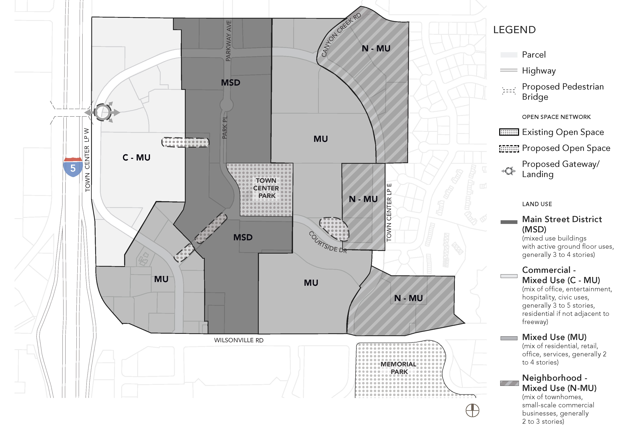

(.03) Permitted and Prohibited uses in specific sub-districts
Figure 1, Land Use Sub-Districts, illustrates subareas of the Town Center where certain regulations apply. Below are use-related regulations for the sub-districts.

Commercial-Mixed Use (C-MU)
- Additional permitted uses – Commercial recreation with outdoor facilities (e.g. cart track); single-user commercial or retail (e.g. grocery store or retail establishment) may exceed 30,000 square feet if located on more than one story of a multi-story building; cinemas.
- Multiple-family dwelling units are prohibited immediately adjacent to I-5. Multiple-family development must be buffered from I-5 by non-residential building(s).
- Uses with drive-through facilities – New uses with drive-through facilities (e.g. fast food, banks, car wash) are permitted in the C-MU sub-district, provided that they meet design and development standards for the TC Zone. Existing drive-through uses and facilities may be continued consistent with Section 4.189.

Main Street (MS)
1. Uses with drive-through facilities – New uses with drive-through facilities (e.g. fast food, banks, car wash) are prohibited. Existing drive-through uses and facilities may be continued consistent with Section 4.189. In the MS sub-district, a change in use is prohibited for new drive-through uses.

Mixed Use (MU)
- Additional permitted uses – Single-user commercial or retail (e.g. grocery store or retail establishment) may exceed 30,000 square feet if located on more than one story of a multi-story building.
- Uses with drive-through facilities – New uses with drive-through facilities (e.g. fast food, banks, car wash) are permitted in the MU sub-district, provided that they meet design and development standards for the TC Zone. Existing drive-through uses and facilities may be continued consistent with Section 4.189.

Neighborhood-MIXED USE (N-MU)
- Uses with drive-through facilities – New uses with drive-through facilities (e.g. fast food, banks, car wash), are prohibited. Existing drive-through uses and facilities may be continued consistent with Section 4.189. In the N-MU sub-district, a change in use is permitted if redeveloping an existing drive-through use with another drive-through use, consistent with the other standards of Section 4.189.

(.04) Consistency with Street Network and Multi-modal Network
- All development will be consistent with the Street Network and Multi-modal Network, shown in Figures 2 and 3. Street and multi-modal facility locations are approximate and will be finalized as part of the development review process. The purpose of these plans are to support the creation of a highly connected and walkable Town Center where there are options for travel. The Development Review Board (DRB) may approve variations from Figures 2 and/or 3, if:
  - Existing development restricts the connection from being developed;
  - Existing natural resources and/or open space would be adversely affected by construction of the facility and mitigation of those impacts is not feasible.

- If a street or other multimodal connection varies from Figures 2 and/or 3, equivalent connectivity and multi-modal travel options shall be provided as determined in a Transportation Impact Analysis prepared per Section 4.140 and approved by the City Engineer.
C. All development shall provide transportation facilities consistent with the cross-sections in the Wilsonville Town Center Plan and applicable provisions of the Wilsonville Transportation System Plan subject to variations approved by the City Engineer.
D. All franchise utilities shall be located underground within the public sidewalk.

Figure 2. Street Network
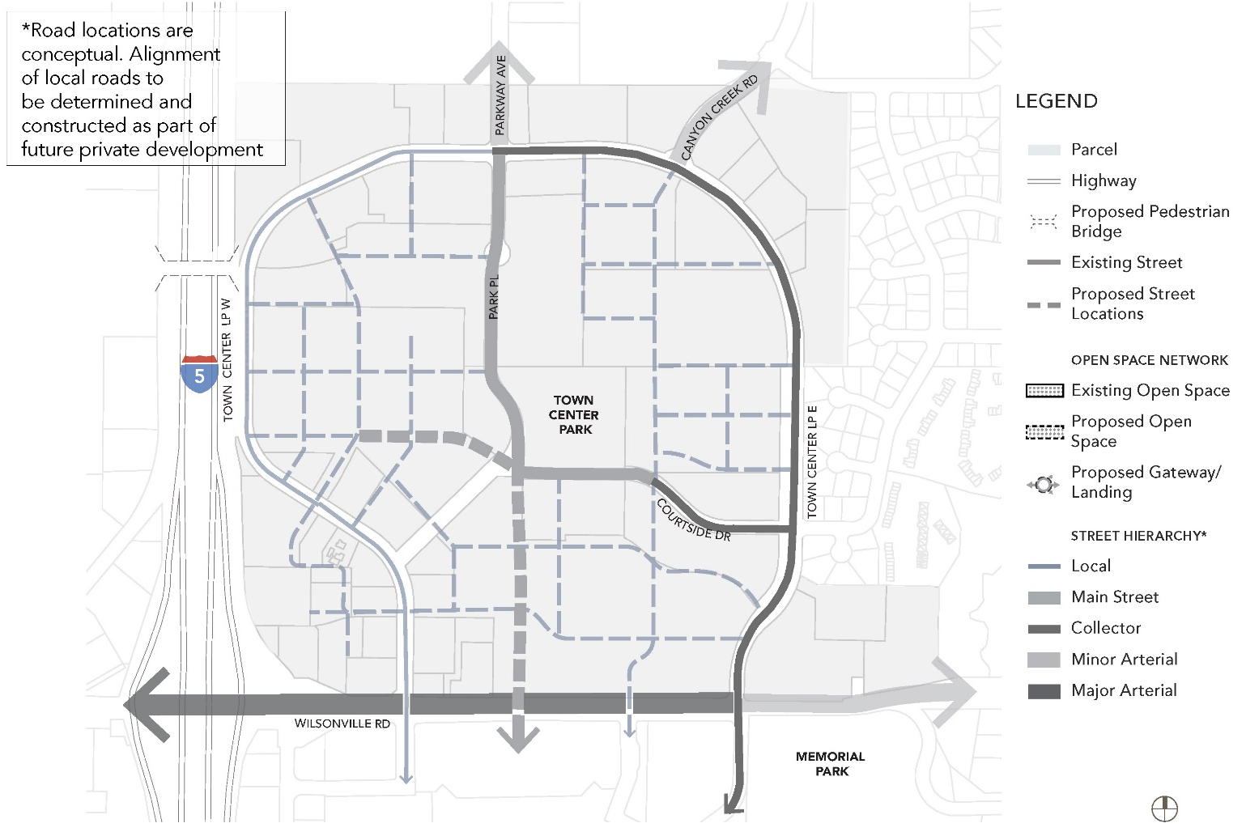

Figure 3. Multimodal Network
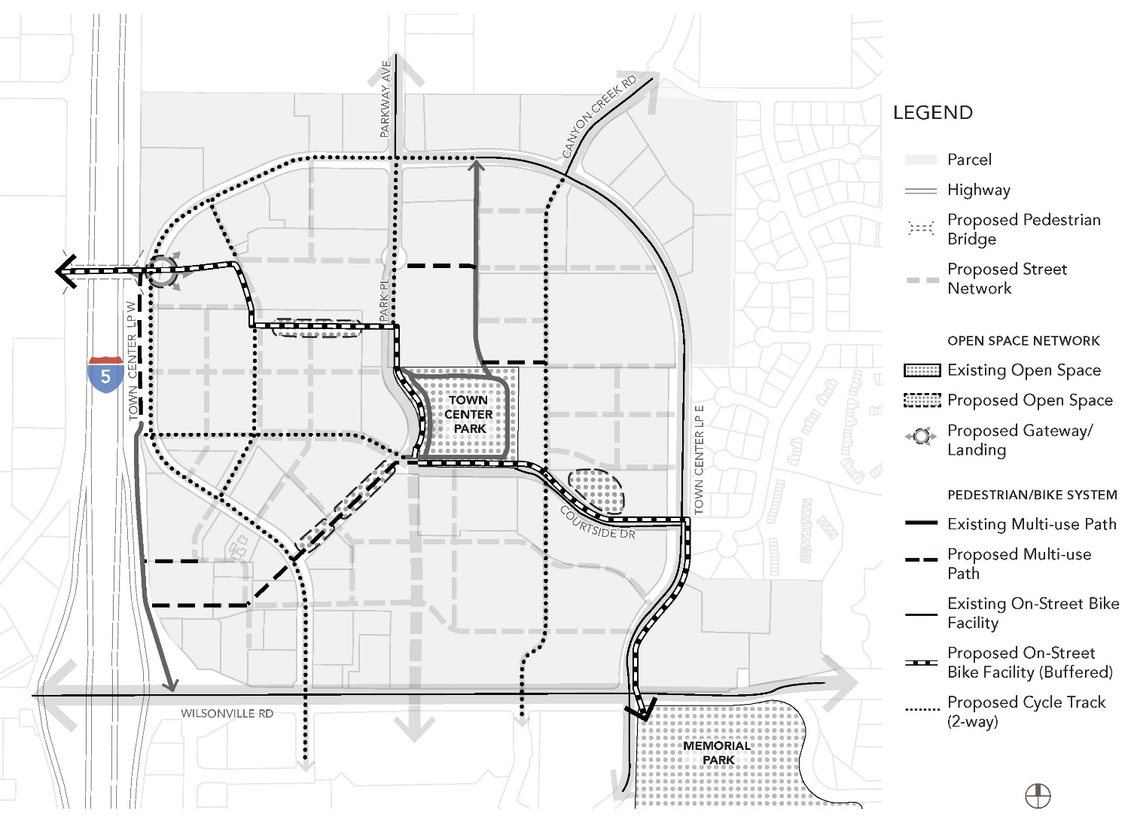

(.05) Consistency with Open Space Network
- All development will be consistent with the Open Space Network, shown in Figure 4. The open space sizes and locations on Figure 4 are approximate and will be finalized as part of the development review process. The purpose of the plan is to create open spaces that are linked and serve as attractive amenities for Town Center. The Development Review Board may approve variations from Figure 4 if needed to accommodate existing development or physical constraints, and/or, preserve natural resources and open space. If an open space is varied, equivalent open space and open space linkage shall be provided.
- The Development Review Board may specify the method of assuring the long-term protection and maintenance of open space and/or recreational areas. Where such protection or maintenance are the responsibility of a private party or homeowners’ association, the City Attorney shall review any pertinent bylaws, covenants or agreements prior to recordation.

Figure 4. Open Space Network
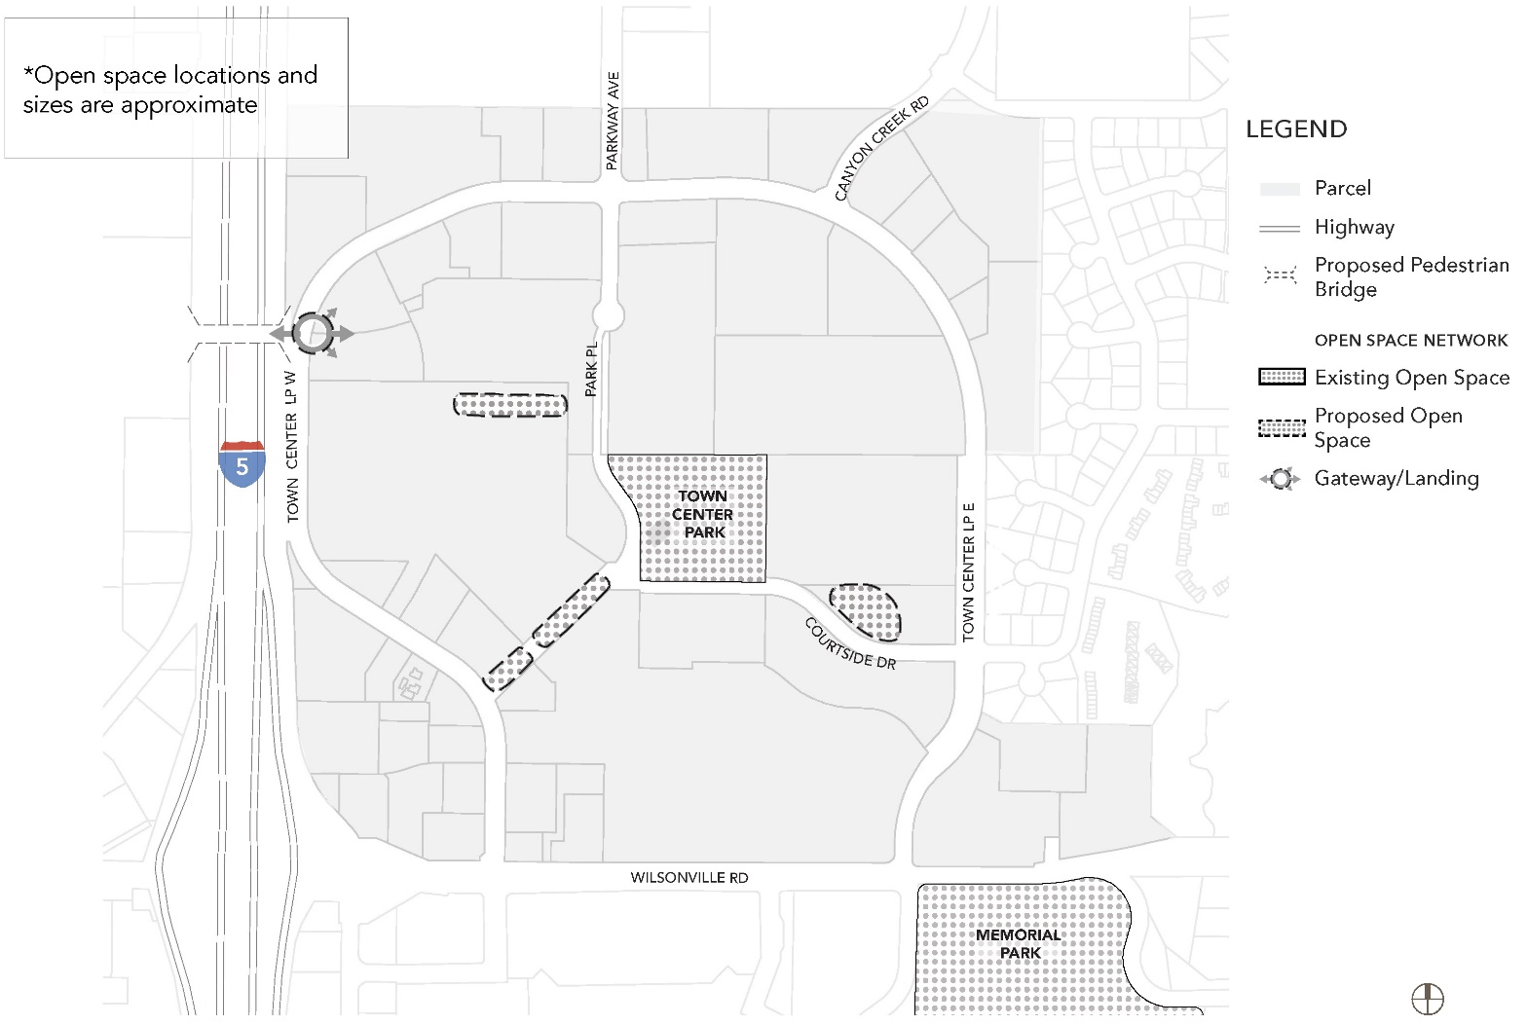

(.06) Design and Development Standards

Purpose and Intent
The purpose of the design standards is to:
- Provide high quality design in new development and redevelopment that promotes a sense of community identity and implements the Wilsonville Town Center Vision.
- Provide a well-defined pedestrian, bicycle and vehicular network, good connections to adjacent land uses and direct connections to transit stops.
- Provide quality and usable open space, increase street tree canopy, and create transitions between land uses.
- Provide sustainable development through the adaptive reuse of existing buildings and increase the use of low-impact development best practices.
- All development shall follow these standards except as permitted in Subsection 4.132 (.06) D.

Building/Street Frontage Requirements
Building and street frontage requirements in this section are intended to create an active pedestrian environment through sidewalk-facing ground floors and entryways with protection from the elements for pedestrians.
Table 1. Building/Frontage Design Standards.
Street type | Main Street | Local Roads | Collectors | Arterial | Multi-Use Paths
Objective | Provides pedestrian-oriented and active building frontage on street. | Provides local access to adjacent development with pedestrian design focus. Local roads should also provide access to parking and service entrances. | Provides capacity to accommodate multimodal transportation access and connectivity to regional connections. | Provides connectivity to regional system focused on moving people. Access from adjacent multimodal networks is focused at signalized intersections. | Provides bicycle, and pedestrian connectivity travel within Town Center and connections to larger bike/ped system.
Sidewalks | Required. Separated from curb by planting strip, tree wells, or rain gardens. | Required. Separated from curb by planting strip, tree wells, or rain gardens. | Required. Separated from curb by planting strip, tree wells, or rain gardens. | Required. Separated from curb by planting strip, tree wells, or rain gardens. | N/A
Sidewalk width (curb to building) [1] | 12 feet, plus optional setbacks.  10 feet fronting Town Center Park. | 12-14 feet, depending on local street option. | 12-13.5 feet (per TSP). | 13.5-16.5 feet (per TSP). | Varies-minimum 12 feet.
Landscaping type | Street trees and plantings, including rain gardens, rooftop gardens, plazas. | Street trees and plantings, including rain gardens, rooftop gardens, plazas. | See Section 4.176. | See Section 4.176. | See Section 4.176.
On-street parking | Parallel or diagonal parking required.  Parklets and bicycle parking permitted in street [2]. | Dependent on local road design (see cross section options). Parallel parking on both sides, or diagonal parking on one side, depending on ROW availability and street cross-section. | Optional | Prohibited | N/A
Number of lanes | Two | Two | Two | Three to five | N/A
Bicycle facilities | See Figure 3.  One-way buffered bike lanes required north of Town Center Park.  Two-way cycle track adjacent to Town Center Park and on Courtside Drive from Park Place to Town Center Loop East. | Varies by local street option. | Buffered, one-way, except where two-way cycle track is recommended (see Figure 3). | Buffered, one way. | N/A
Minimum % of building along street frontage  (see Figures 5.A through 5.D for typical site designs) | Minimum 70% of buildings facing main street. Buildings to be placed at corners with primary building access at or within 20 feet of the corner. | Minimum 50% of building facing a local street. Buildings to be placed at corners. | Minimum 50% | Minimum 50% | N/A
Location of parking | On street, behind building (surface or structured, above or below grade)), or at shared central location. | On street when allowed, behind or to the side of building.  Off street parking is not permitted along main street frontage.  Off-street parking prohibited at corners of public streets. | To the back or side of building.  Off-street parking prohibited at corners of public streets. | To the back or side of building.  Off-street parking prohibited at corners of public streets. | N/A
Parking access | Parking access provided via local street, alley, or midblock crossing. Alleys must be located more than 100 feet from another road or access point. Shared access is encouraged. Parking access is restricted on north/south main street unless no other access is feasible. | Parking access provided via local access street or alley. | Parking access provided via local street. | Not permitted. Access to be provided at signalized intersections and interior circulation system. | N/A
Driveway spacing standards | 100 ft. min | 100 ft. min | 100 ft. min | N/A | N/A
Block length | Maximum block length is 400 ft. The maximum distance to a pedestrian mid-block crossing shall be 250 ft. Maximum mid-block crossing width up to 20 ft. | Maximum block length is 400 ft. The maximum distance to a pedestrian mid-block crossing shall be 250 ft. to provide pedestrian and parking access. Maximum mid-block crossing width up to 30 ft. | N/A | N/A | N/A
Typical vehicle speed | 20-25 mph | 20-25 mph | 25-30 mph | 25-35 mph | N/A
[1] Sidewalk width includes landscaping area. Tree wells shall include root barriers, the use of structural soils, soil cells, or other means to minimize impacts to sidewalks or roadway from root intrusion.
[2] A maximum of two parklets are permitted per block, per side of street.
Figure 5.A. Building Placement and Location of Parking, Main Street Intersection (typical)
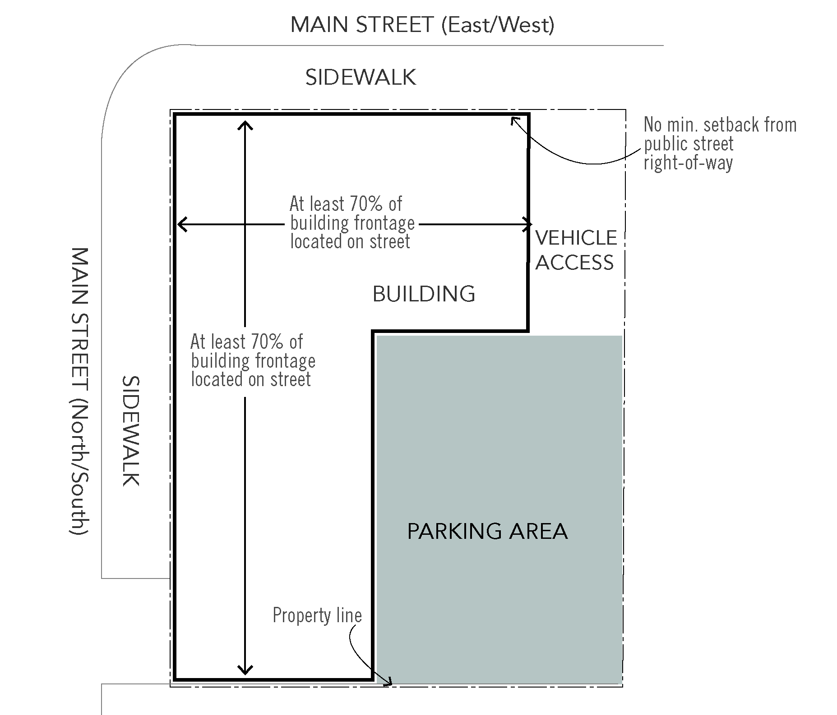
Figure 5.B. Building Placement and Location of Parking, Main Street/Local Street Intersection (typical) 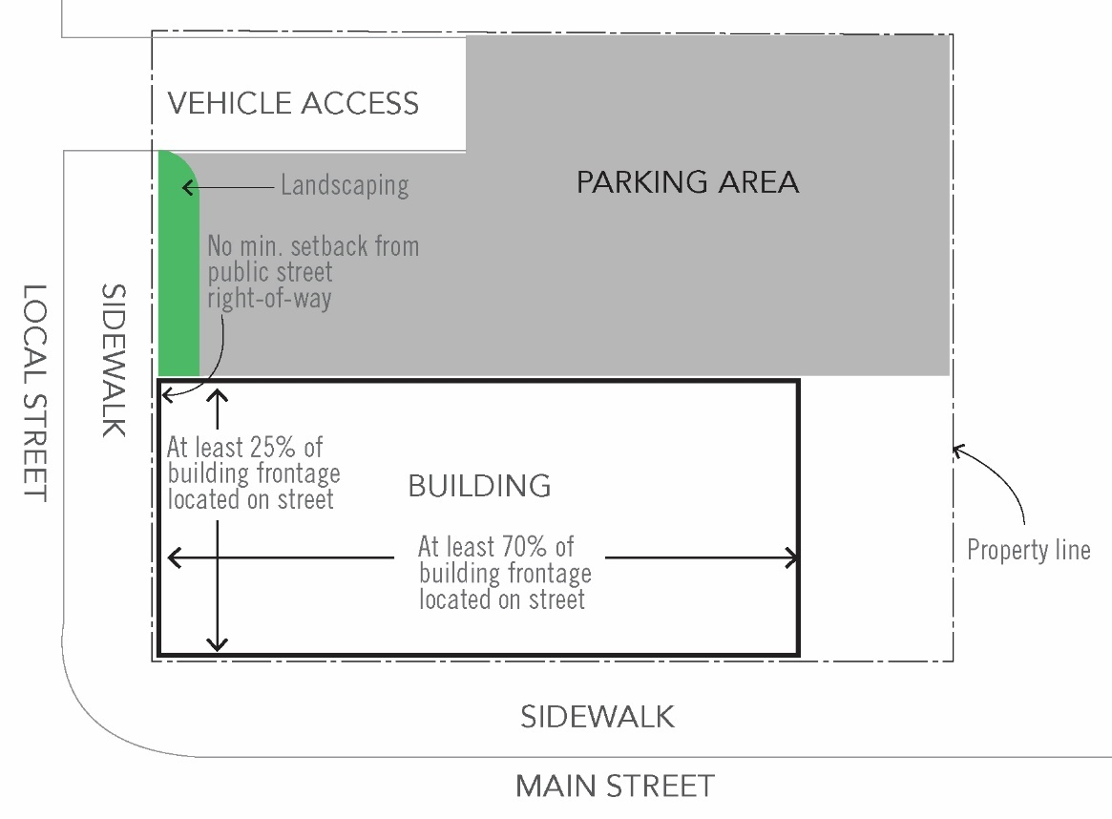

Figure 5.C. Building Placement and Location of Parking, Local Street/Local Street Intersection (typical)
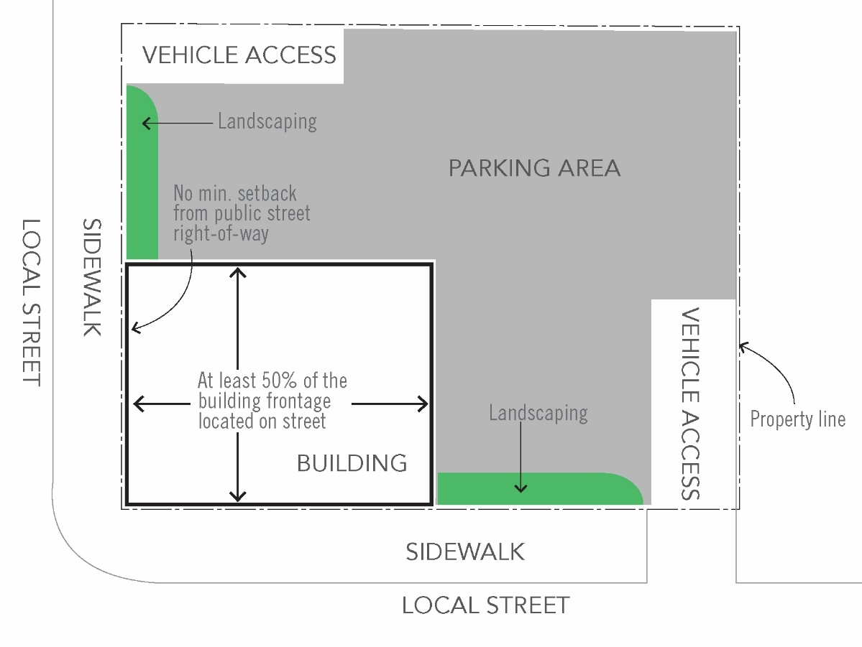
Figure 5.D. Building Placement and Location of Parking, Arterial/Collector/Local Street frontage (typical)
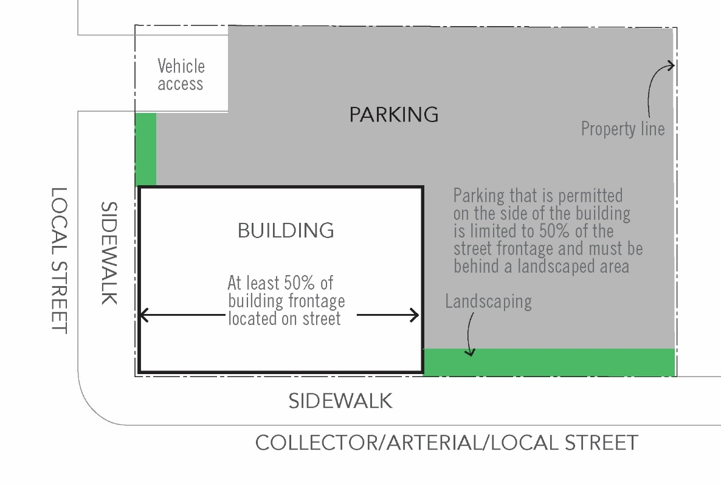

C. Development Standards
Development standards apply to all new development within the Town Center boundary.
Table 2. Town Center Development Standards [1]
 | Town Center
STANDARD | SUB-DISTRICT
 | MSD | N-MU | MU | C-MU
Front setback
Minimum | 0 ft. | 0 ft. | 0 ft. | 0 ft.
Maximum [2] | 20 ft. | 20 ft. | 20 ft. | 10 ft.
Side facing street on corner and through lots
Minimum | 0 ft. | 0 ft. | 0 ft. | 0 ft.
Maximum [2] | 10 ft. | 10 ft. | 10 ft. | 10 ft.
Side yard
Minimum | 0 ft. | 0 ft. | 0 ft. | 0 ft.
Maximum [2] | 10 ft. | 10 ft. | 10 ft. | 10 ft.
Rear setback
Minimum | 0 ft. | 0 ft. | 0 ft. | 0 ft.
Maximum | 20 ft. | 20 ft. | 20 ft. | 20 ft.
Building height (stories) [3]
Minimum | two | two | two | two
Maximum (stories/feet) [4] | four | three | four | five
Ground floor height minimum [5] | 15 ft. | 12 ft. | 12 ft. | 15 ft.
Ground floor uses | Mixed-use buildings required within 200 feet of the Park Place/Courtside Drive intersection. | N/A | N/A | N/A
Building site coverage maximum | 90% | 75% | 90% | 90%
Minimum landscaping | 10% | 15% | 15% | 10%
Minimum building frontage | 70% | 25% | 50% | 50%
Residential density (units per acre)
Minimum [6] | 40 | 16 | 40 | 40
Maximum | None | 40 | None | None
[1] This table does not apply to existing development. All new buildings in the district must meet these development standards.
[2] For commercial development, the maximum front and street side yard setback is 10 feet. For mixed-use and residential only development, the maximum front setback is 20 feet. Front setbacks are permitted provided they are used for seating or other uses that encourage pedestrian activity and active ground floor uses. A variety of building setbacks are encouraged.
[3] Second stories or higher in buildings must be useable. No false front buildings are permitted.
[4] Within the MSD, MU and C-MU sub-districts, the maximum number of building stories may be increased by one story if a minimum of 25% of the units of the bonus floor area are affordable, with rental rates /mortgage restrictions for a minimum of 10 years, to households earning at or below 80% of median family income of Wilsonville.
[5] This standard does not apply to residential only buildings.
[6] Minimum residential density applies to residential-only development. There is no minimum residential density for mixed-use development.

D. Waivers to Development Standards
The Development Review Board (DRB) may approve waivers to the size of the ground floor of a building floorplate and/or the number of stories of a building within the MU and C-MU sub-districts, consistent with the provisions of Section 4.118 (.03) if one item from each of the two following menus are met in a manner to clearly go substantially above and beyond code requirements and typical building and site design to create a sense of place and mitigate negative impacts of the project related to the reason for the waiver. Items chosen from the menus shall account for need based on adjacent sites or the surrounding area:
Menu One
1. Public amenities, such as a plaza or other community gathering space, incorporated into the building design. Public plaza or other gathering spaces located in a prominent, visible location adjacent to a public street and include movable furniture that is functional and visually interesting.
2. Public community meeting space provided within the building.
3. Provision of ground floor facades that include additional supporting storefronts. The primary entrance of all businesses shall be located on the primary street frontage.
4. Provision of incubator space on site, either within or adjacent to the development that provides below market lease rates for small businesses.
5. Provision of affordable housing on the development site, consistent with the provisions of Table 2, footnote 4.
Menu Two
1. Innovative building techniques, such as rainwater harvesting, graywater systems, green roofs, or other environmental systems, shall be incorporated into the building design to significantly reduce impact to the environment.
2. Building architecture that creates a distinctive community landmark exemplifying the preferred materials and form for Town Center described in Subsection 4.132 (.06) M. and discussed in the Town Center Plan.
3. Pedestrian-oriented and creative lighting incorporated into landscape features and plazas and/or interior window retail displays that are lit at night.
4. Achievement of LEED certification, Earth Advantage, or another recognized environmental certification.
5. Installation of public art, consistent with the provisions of Subsection 4.132 (.06) K. for art within plaza areas.

E. Building Placement
Buildings shall meet the following standards:
1. Main Streets and Local Streets. Where parcels are bounded by a main street and perpendicular street, buildings shall be located at the street intersection. For parcels with frontage only on one street or if a building is already located at the street intersection, the new building shall be located immediately adjacent to existing building to create a continuous building façade with adjacent buildings. Street frontage requirements for main street are a minimum of 70 percent of the lot frontage. Off-street parking shall be located behind buildings fronting main street, either on surface or tuck under lot, parking structure, or at a central off-site parking facility located within the TC boundary.
2. If a parcel fronts two or more different street design classifications, the primary building entrance shall front the following in order of priority: main street, local street, collector street.
3. Minimum building frontage requirements for a local street shall be 25 percent if the development also fronts main street.
4. Minimum building frontage requirements for a local street shall be 50 percent if the development fronts another local street.
5. For parcels that do not front a main street or a local street, the minimum building frontage shall occupy a minimum 50 percent of the lot frontage.
6. The Development Review Board may approve variations from building placement standards if existing development, physical constraints, or site circulation and access are infeasible. If the Development Review Board determines that a variation from building placement standards is required, building placement should be prioritized as follows:
a. If the development is adjacent to main street, the primary frontage of the building shall remain on main street with variation from this standard occurring on a side street.
b. If the development is adjacent to the main streets (e.g. Park Place and Courtside Drive) the primary frontage shall be on Park Place with the variation occurring on Courtside Drive.
c. If the development is adjacent to two local streets, the primary frontage shall be on the north/south local street with the variation occurring on east/west local street.
F. BUILDING SETBACKS
The minimum building setback from public street rights-of-way shall be zero feet; the maximum building setback shall be 20 feet for MSD and N-MU districts. The maximum setback shall be 10 feet for all other districts. No off-street vehicle parking or loading is permitted within the setback. Bicycle parking is permitted with in the setback.

g. Front yard setback design
Landscaping, water quality treatment, seating areas, an arcade, or a hard-surfaced expansion of the pedestrian path must be provided between a structure and a public street or accessway. If a building abuts more than one street, the required improvements shall be provided on all streets. Hard-surfaced areas shall be constructed with scored concrete or modular paving materials. Benches and other street furnishings are encouraged.

h. Walkway connection to building entrances
A walkway connection is required between a building’s entrance and a public street or accessway. This walkway must be at least six feet wide and be paved with concrete or modular paving materials. Building entrances at a corner adjacent to a public street intersection are encouraged.

i. Parking location and landscape design
1. Parking for buildings adjacent to public street rights-of-way must be located to the side or rear of newly constructed buildings, except for buildings fronting main street, where parking must be located behind the building, either surface, tuck under or structured (above or below grade). For locations where parking may be located to the side of the building, parking is limited to 50% of the street frontage and must be behind a landscaped area per Section 4.176.
2. Within off-street parking lots, all parking spaces, except for those designated for ADA accessible space or deliveries, shall be shared spaces. Designation for individual uses is not permitted.
3. Within off-street parking lots, time limitations may be placed on parking spaces to encourage parking turnover. This includes time limitations to pickup and drop off of goods from area businesses (e.g. drycleaner, bank ATM etc.).

j. Parking Garages and off-street parking access
Parking garages must meet all building standards identified within this section. Off street access to a parking lot or garage should be located to minimize conflicts with pedestrians and must be provided from an alley or local street.

k. Plaza areas
The following plaza design standards are intended to enhance the overall site layout and ensure that plaza areas are designed as an accessible amenity.
1. Plaza space shall be required when a mixed-use or commercial development or redevelopment involves a gross site area greater than two acres. When a plaza is required as a percentage of the overall required open space the plaza space shall incorporate at least three of the following elements:
a. One seating space is provided for every 250 square feet of plaza area and/or public space. The seating space requirement may be met by providing benches, chairs, and/or seat-walls. Areas actively used for public outdoor cafes are exempted from the calculation in the seating area requirement. Remaining plaza areas must meet the seating requirement.
b. Structures such as pergolas, canopies, awnings, arcades, or other similar elements to provide shade and rain coverage. Structures should provide coverage for year-round use of the plaza.
c. Notwithstanding trees required to satisfy the open space requirement, additional trees are provided at a rate of one tree per 800 square feet of plaza or public space area.
d. Water features.
e. Public art. Public art that is proposed or provided must satisfy all of the following requirements:
i. The art must be designed and produced by a professional artist;
ii. The art must relate in terms of scale, material, form and content to immediate and adjacent buildings and architecture, landscaping or other settings so as to complement the site and its surroundings;
iii. The art must demonstrate excellence in craftsmanship, originality in conception, and integrity of materials. Interactive art is encouraged;
iv. Minimal maintenance must be adequate for preserving the long-term integrity and enjoyment of the art, as evidenced by a maintenance plan submitted with the public art proposal;
v. Art in private construction projects must be maintained by the property owner in a manner acceptable to the City in accordance with a maintenance plan submitted with the art proposal;
vi. The art must meet all applicable building code requirements.
vii. The art must be accompanied by an identifying plaque that features the artist’s name, artwork title and date of completion. This plaque must be made of a durable material and be installed permanently near the art.
f. Activity areas including but not limited to outdoor cafes, retail spaces, and/or programmed spaces that accommodate entertainment, meetings, educational activities, and play areas.
g. Pedestrian-scale wayfinding.
2. Plaza areas shall be visible and accessible from adjacent streets or pedestrian areas. A minimum of 75 percent of the plaza frontage shall provide direct unobstructed access from adjacent streets.
3. Stormwater management facilities shall be integrated into the plaza design and used as an amenity to the greatest extent possible.
4. No less than 20 percent or more than 60 percent of the plaza area shall be utilized for planted landscaping, including stormwater detention areas. All other areas shall be composed of hardscaping.
5. The minimum size of a plaza shall be 2,000 square feet.
6. Litter receptacles shall be provided at a minimum of four cubic feet of capacity per 800 square feet of open plaza space.

l. Drive Through Facilities
A drive-through facility shall be subject to the following standards:
1. Shall only be permitted if the building also includes indoor seating.
2. Shall not be permitted on parcels with frontage on a main street.
3. All traffic queuing using the drive through facilities shall be accommodated on site and shall not conflict with bicycle and pedestrian mobility adjacent to the site.
4. A drive-through lane shall not be located in the area between a building and a public street and the drive-through windows shall not face a public street.
5. In addition to standards for drive throughs, buildings with drive-through facilities shall also meet standards for primary building access (Subsection 4.132 (.06) M. 2. h.).
6. Drive-through facilities shall be clearly marked with signage to avoid conflict with on site and adjacent pedestrian and bicycle facilities.

Figure 6. Drive Through Facilities in Town Center, if not enclosed in a structure (typical)
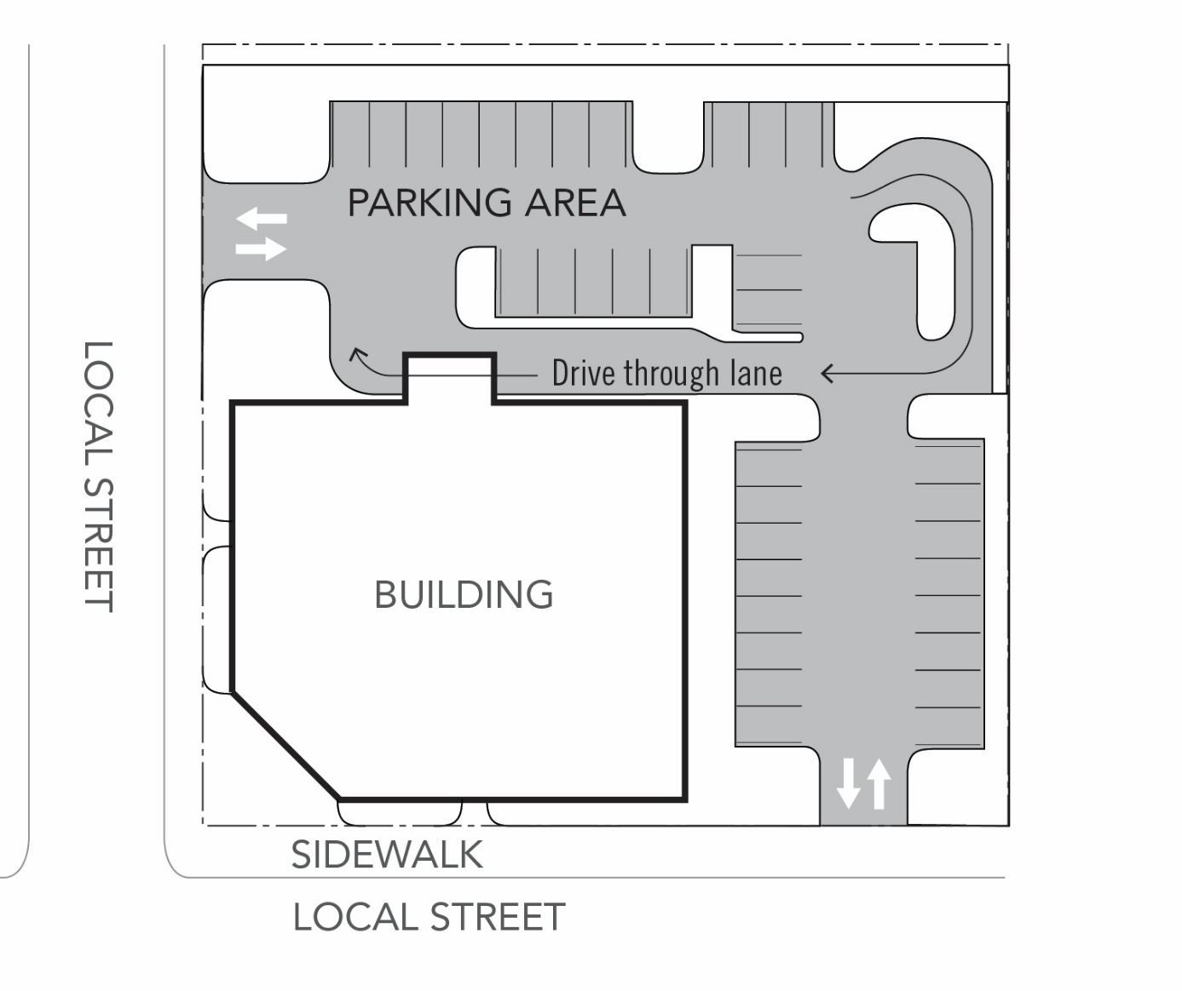

m. Building Design Standards

1. General Provisions
a. The first-floor façade of all buildings, including structured parking facilities, shall be designed to encourage and complement pedestrian-scale interest and activity through the use of elements such as windows, awnings, and other similar features.
b. Building entrances shall be clearly marked, provide weather covering, and incorporate architectural features of the building.
c. Architectural features and treatments shall not be limited to a single façade. All visible sides of a building from the street, whether viewed from public or private property, shall display a similar level of quality and architectural interest, with elements such as windows, awnings, murals, a variety of exterior materials, reveals, and other similar features.
d. Green building techniques are encouraged, which could include the use of green roofs, gray water and water harvesting, and/or LEED certification of buildings.

2. Design Standards
Ground Story: Mixed Use and Non-Residential | 60% of facade
Upper Stories: Mixed Use | 30% of facade
Ground Story: Residential Only | 30% of facade
a. All buildings, including parking garages, shall comply with the following design standards. Building facade windows are required on all street-facing facades (see Figure 7), as follows:

i. Window area is the aggregate area of the glass within each window, including any interior grids, mullions, or transoms. Facade area is the aggregate area of each street-facing vertical wall plane.
ii. Required windows shall be clear glass and not mirrored or frosted, except for bathrooms. Clear glass within doors may be counted toward meeting the window coverage standard.
iii. Ground floor windows. All street-facing elevations within the building setback (zero to 20 feet) along public streets shall include a minimum of 60 percent of the ground floor wall area with windows, display areas or doorway openings. The ground floor wall area shall be measured from two feet above grade to ten feet above grade for the entire width of the street-facing elevation. The ground floor window requirement shall be met within the ground floor wall area and for glass doorway openings to ground level. Up to 50 percent of the ground floor window requirement may be met on an adjoining elevation as long as the entire requirement is located at a building corner.
iv. Street-facing facades that contain vehicle parking, such as a parking structure, do not have to provide windows but shall provide facade openings that meet the minimum required window area. If required facade openings do not contain glass, they may contain architectural elements that are no more than 30 percent sight-obscuring.
b. Building Facades
i. Facades that face a public street shall extend no more than 50 feet without providing at least one of the following features: (a) a variation in building materials; (b) a building off-set of at least one foot; (c) a wall area that is entirely separated from other wall areas by a projection, such as an arcade; or (d) by other design features that reflect the building’s structural system (See Figure 8). No building façade shall extend for more than 250 feet without a pedestrian connection between or through the building (see Figure 11).
ii. Buildings more than three stories are required to step back six feet from the building facade at the beginning of the fourth story.
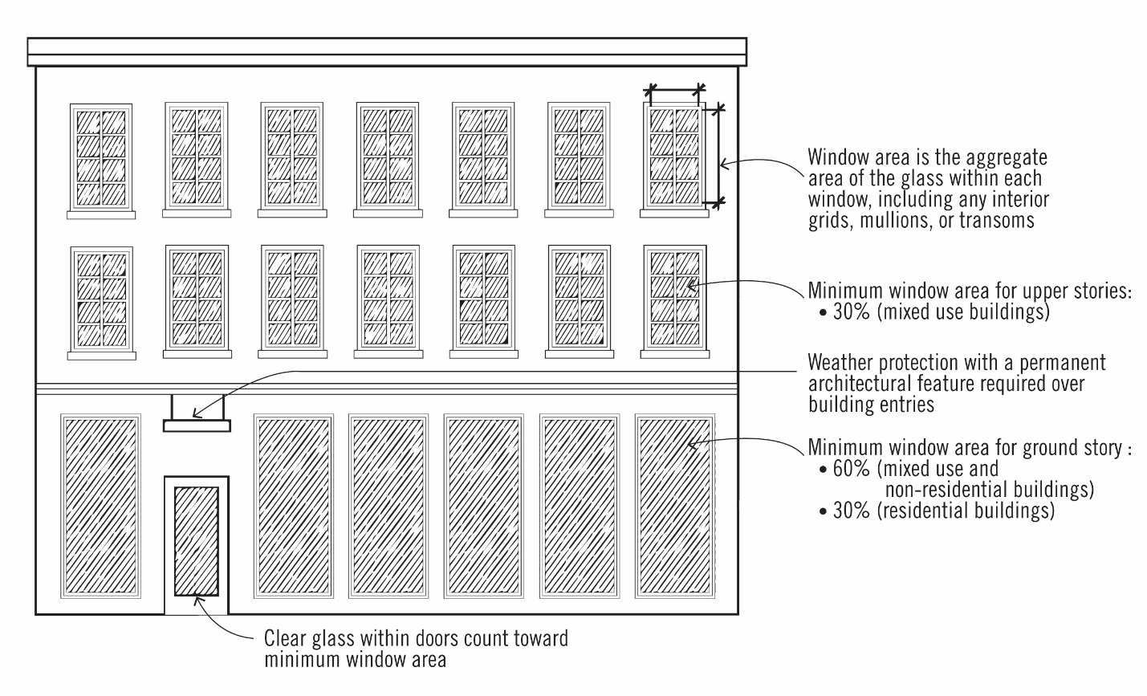
Figure 7. Window Placement and Percentage of Facade

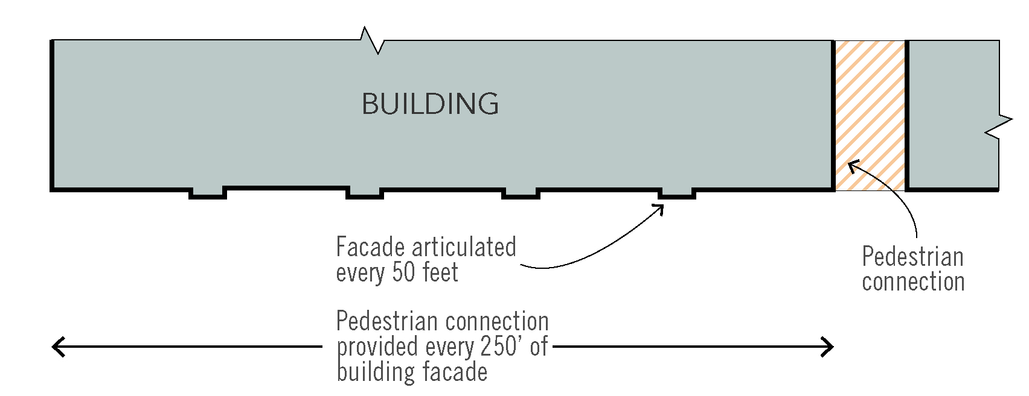
Figure 8. Building Facade Articulation and Stepbacks
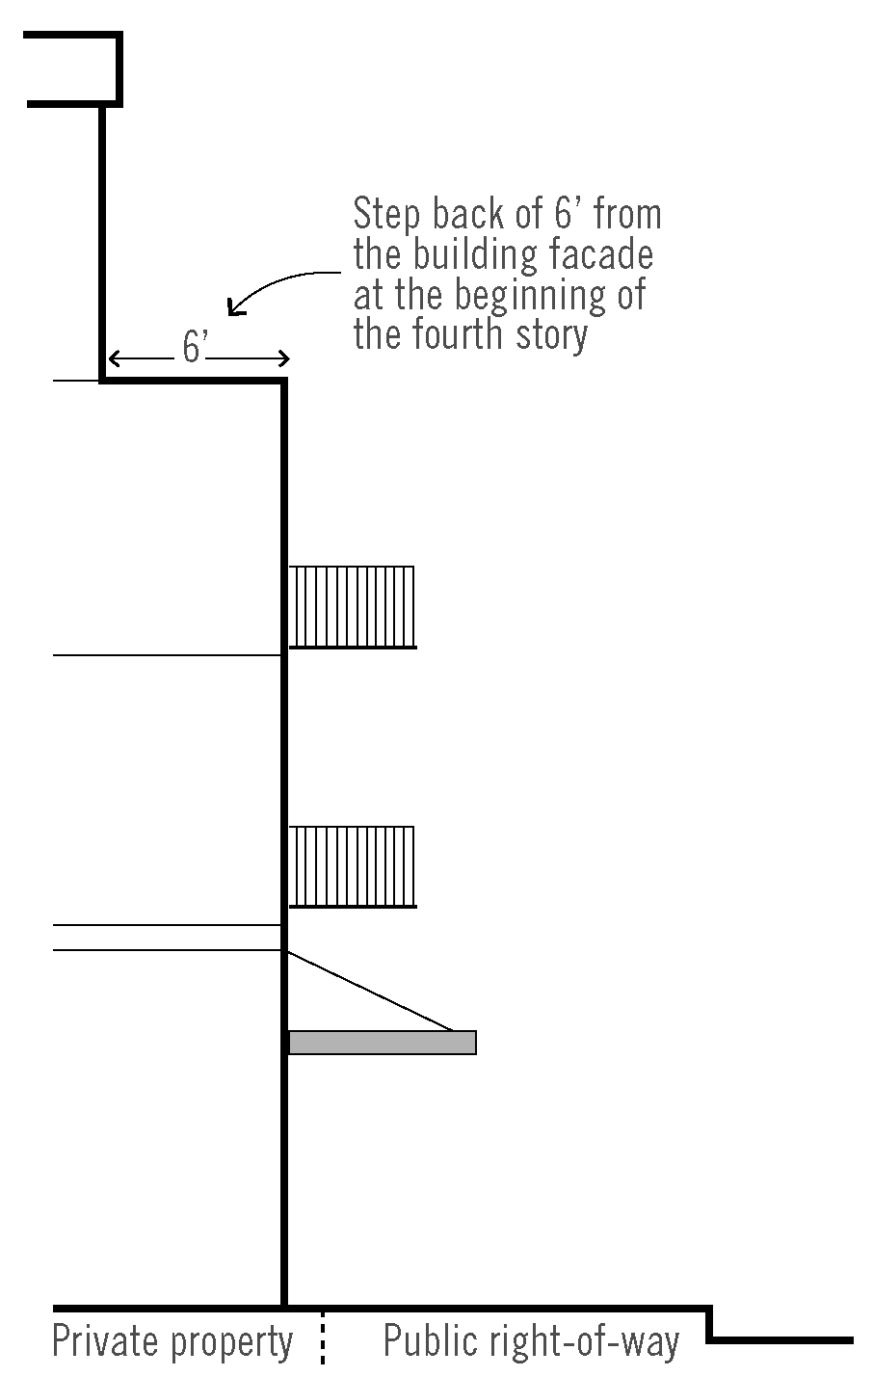

c. Weather protection (for non-residential and mixed-use buildings):
i. A projecting facade element (awning, canopy, arcade, or marquee) is required on the street-facing façade. Within the MSD sub-district, weather protection shall be provided across the entire length of the building frontage.
ii. All weather protection must comply with the Oregon Structural Specialty Code in effect at the time of application for projections or encroachments into the public right-of-way.
iii. Weather protection shall be maintained and in good condition.
iv. Marquees shall have a minimum 10-foot clearance from the bottom of the marquee to the sidewalk. Canopies and awnings shall have a minimum 8-foot clearance from the bottom of the awning or canopy to the sidewalk.
v. The projecting façade element shall not extend into amenity zone or conflict with street lights. If the projecting façade element blocks light shed from adjacent street lights, exterior lighting shall be located on the building.
vi. Awnings shall match the width of storefronts or window openings.
vii. Internally lit awnings are not permitted.
viii. Awnings shall be made of glass, metal, or a combination of these materials. Fabric awnings are not permitted.
d. Building materials. Plain concrete block, plain concrete, T-111 or similar sheet materials, corrugated metal, plywood, sheet press board or vinyl siding may not be used as exterior finish materials. Foundation material may be plain concrete or plain concrete block where the foundation material is not revealed for more than two feet. Use of brick and natural materials (wood) is encouraged.
e. Roofs and roof lines. Except in the case of a building entrance feature, roofs shall be designed as an extension of the primary materials used for the building and should respect the building’s structural system and architectural style. False fronts and false roofs are not permitted.
f. Rooftop features/equipment screening
i. The following rooftop equipment does not require screening:
- Solar panels, wind generators, and green roof features;
- Equipment under two feet in height.
ii. Elevator mechanical equipment may extend above the height limit a maximum of 16 feet provided that the mechanical shaft is incorporated into the architecture of the building.
iii. Satellite dishes and other communications equipment shall be limited to 10 feet in height from the roof, shall be set back a minimum of five feet from the roof edge and screened from public view to the extent possible.
iv. All other roof-mounted mechanical equipment shall be limited to 10 feet in height, shall be set back a minimum of five feet from the roof edge and screened from public view and from views from adjacent buildings.
v. On all structures exceeding 35 feet in height, roofs shall have drainage systems that are architecturally integrated into the building design.
vi. Any external stairwells, corridors and circulation components of a building shall be architecturally compatible with the overall structure, through the use of similar materials, colors, and other building elements.
vii. Required screening shall not be included in the building’s maximum height calculation.
g. General Screening. Utility meters shall be located on the back or side of a building, screened from view from a public street to the greatest extent possible, and shall be painted a color to blend with the building façade.
h. Primary Entry
i. For commercial/institutional/mixed-use buildings:
- At least one entry door is required for each business with a ground floor frontage.
- Each entrance shall be covered, recessed, or treated with a permanent architectural feature in such a way that weather protection is provided.
- All primary ground-floor common entries shall be oriented to the street or a public space directly facing the street, or placed at an angle up to 45 degrees from an adjacent street. Primary ground-floor common entries shall not be oriented to the interior or to a parking lot.
- Courtyards, plazas and similar entry features may be utilized to satisfy the building entrance requirement when these features are designed to connect the adjacent street edge to the main building entrance.
ii. For residential buildings:
- Entry door. The primary public entrance to each building unit shall be covered, recessed, or treated with a permanent architectural feature in such a way that weather protection is provided.
- All primary ground-floor common entries of multifamily buildings or individual unit entries of attached residential units that front the street shall be oriented to the street or public right-of-way, not to the interior or to a parking lot.
i. Building projections. Building projections are allowed as follows (see Figure 9):
i. Architectural elements such as eaves, cornices and cornices may project up to one foot from the face of the building.
ii. Bay windows and balconies may project up to four feet from the face of the building. Balconies that project into the right-of-way shall have a minimum vertical clearance of 12 feet from sidewalk grade or be mounted at the floor elevation, whichever is greater.
iii. See also Subsection 4.132 (.06) M. 2. C. for standards related to weather protection.

Figure 9. Building Projections
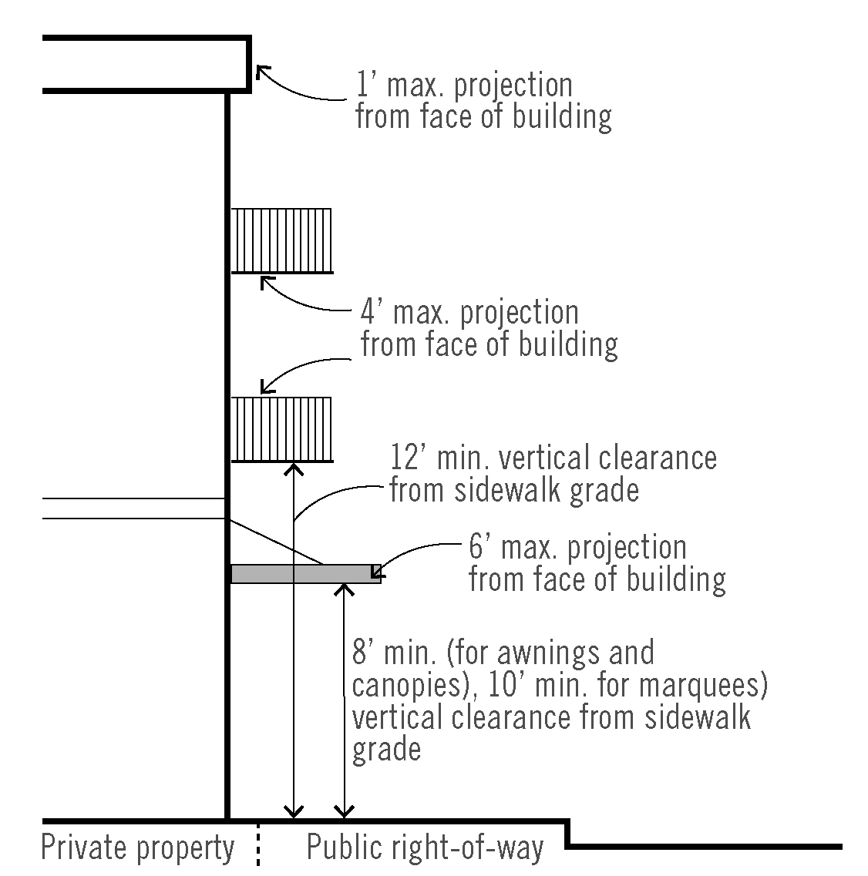

n. Off Street Parking and Loading
Parking standards are identified in Section 4.155.

o. Parking within a Building or Structure
1. Parking structures shall be designed to allow reuse of the building for non-parking uses, such as office or residential uses.
2. The ground floor façade of a structured parking facility that abuts a public sidewalk, street, or open space and that is not occupied by entrances, exits, or waiting areas shall be designed and constructed with a minimum unfinished floor to ceiling height of 15 feet in order to allow occupancy by uses other than parking that are permitted in the underlying district (see Figure 10).
3. Parking structures located in the MSD and adjacent to a public street shall contain retail or office uses on the first floor fronting the street or be wrapped with development of equal or greater height than the parking structure. At least 50 percent of a street-level floor facing a public sidewalk, street, or open space area shall contain retail or office uses to a minimum depth of 60 feet.
4. Facade openings that face a public street or open space shall be vertically and horizontally aligned and all floors fronting on those facades shall be level, not inclined.
5. The first floor facade of a parking structure located adjacent to a public street shall include at least three architectural elements such as arcades, windows, awnings, overhangs, screens, grills, louvers or other similar non-opaque features.
6. Parking structures shall be designed so that motorized vehicles parked on all levels of the structure are screened to a minimum height of 42 inches.
7. Where the upper floors of above-ground parking structures are visible from a public street, such surfaces shall include architectural or vegetative finishes.
8. Within a surface parking lot or structure, the bicycle spaces, carpool, vanpool, shared car, or electric vehicle charging spaces should be placed in preferred locations relative to the street, the building entrances, and the primary pedestrian routes within and around the project site.

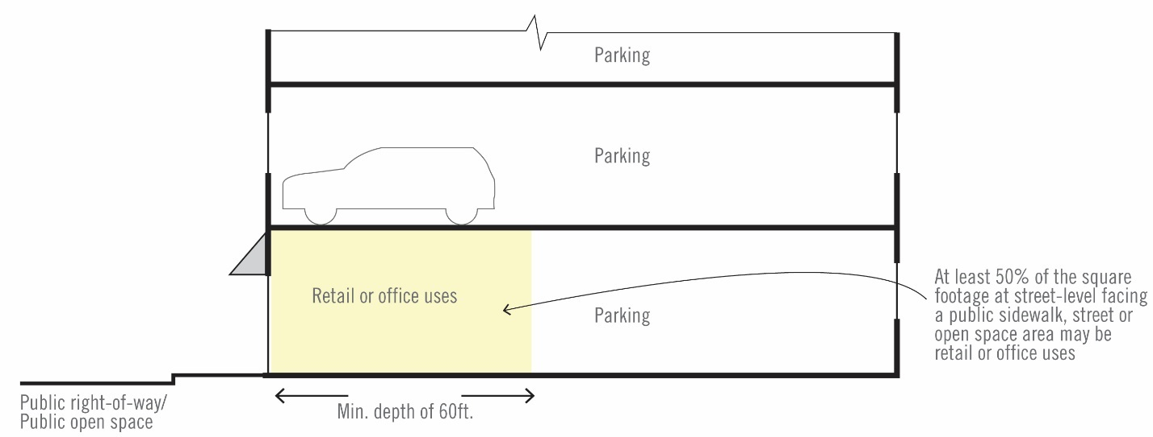
Figure 10 Parking Structure-Ground Floor Design

p. Street Connectivity

1. Purpose
The purpose of these standards and procedures is to create safe, comfortable, and attractive streetscapes for pedestrians, improve connectivity for all modes of travel, and remove barriers for small-scale incremental development.

2. General provisions
This section contains the standards and procedures for improvements to public transportation facilities for all property located in the Wilsonville Town Center Boundary, including specific standards for vehicle, pedestrian, bicycle, and transit facilities. The terms “transportation facilities” and “transportation improvements” generally include those facilities, or improvements to those facilities, that accommodate all modes of travel that are usually located in public rights-of-way, also commonly referred to as streets. “Frontage improvements” are transportation improvements immediately adjacent to a proposed development’s street frontage. “Off-site improvements” are transportation improvements not adjacent to a proposed development’s street frontage.

3. Transportation facility standards.
a. Intersection design and spacing
i. Transportation facilities shall be designed and constructed in conformance to the applicable section of the City Development Code and to the City’s Public Works Standards.
ii. Street intersections shall have curb extensions to reduce pedestrian crossing distances unless there are other standards that apply, such as areas with flush curbs.
iii. New street intersections, including alleys, are subject to approval by the City Engineer.
b. Transportation network connectivity
i. Minimum required transportation improvements are identified in the Wilsonville Town Center Plan. Alleys are encouraged but not required. Private streets are prohibited.
ii. Bicycle and pedestrian connections are required where the addition of a connection would link the end of a permanent turnaround to an adjacent street or provide a midblock connection through a long block. A mid-block connection is required where at least one block face is 400 feet or more in length (see Figure 11). A required connection must go through the interior of the block and connect the block face to its opposite block face. The mid-block crossing shall be demarcated with paving, signage, or design that clearly demarcates the crossing is designated for pedestrian and bicycle crossings.
Figure 11. Mid-Block Pedestrian and Bicycle Connections
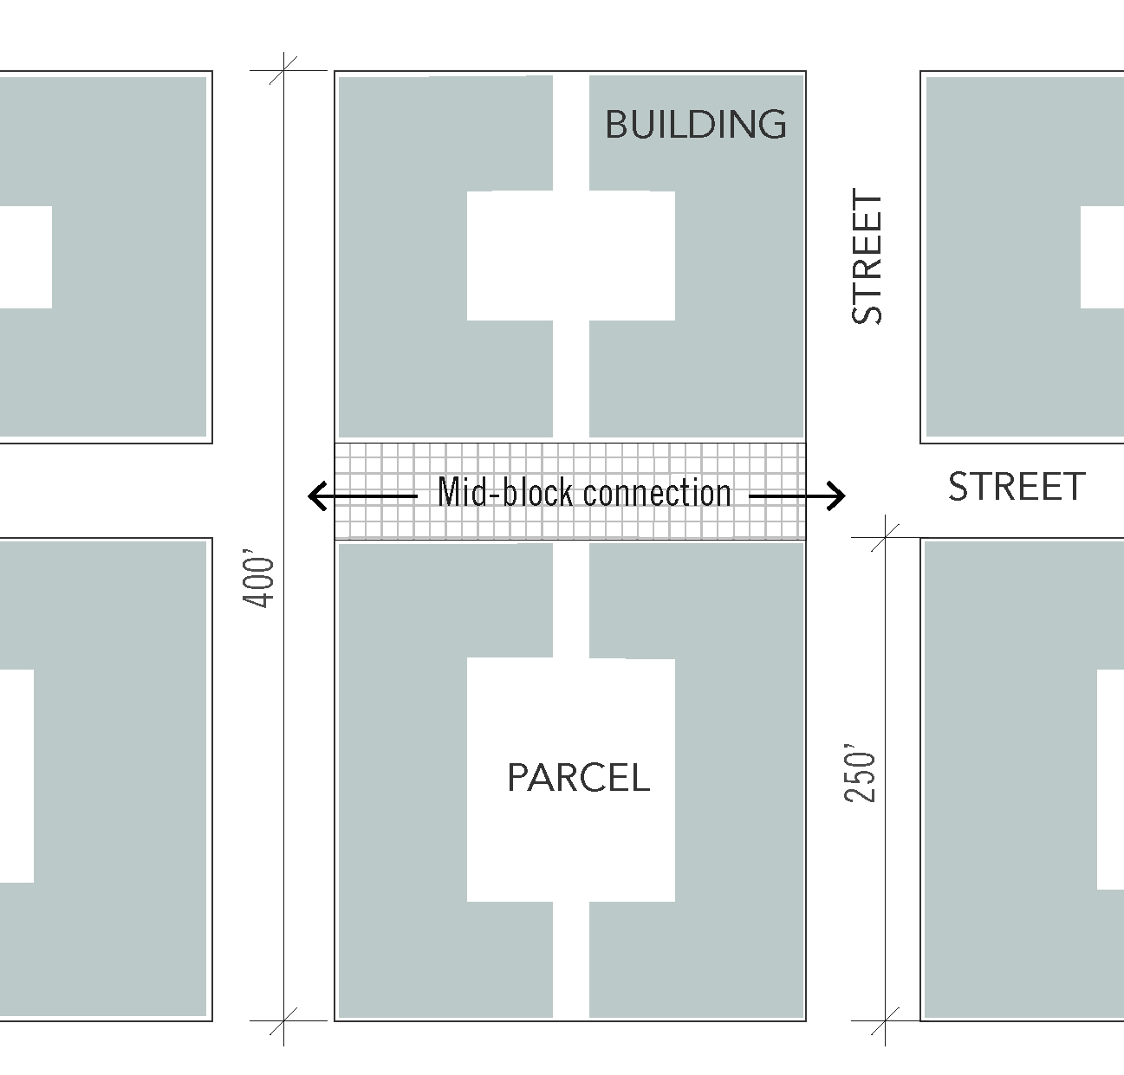
iii. Streets shall be extended to the boundary lines of the proposed development where necessary to give access to or allow for future development of adjoining properties.
- Any required or proposed new streets through or along the boundary of the proposed development shall be accompanied by a future street plan. The future street plan shall show that it is feasible to extend all required or proposed new streets onto adjoining properties to the satisfaction of the City Engineer.
- Temporary turnarounds shall be constructed for street stubs in excess of 150 feet in length. Drainage facilities shall be constructed to properly manage stormwater runoff from temporary turnarounds.
- Street stubs to adjoining properties shall not be considered permanent turnarounds, unless required and designed as permanent turnarounds, since they are intended to continue as through streets when adjoining properties develop.
- Reserve strips may be required in order to ensure the eventual continuation or completion of a street.
iv. Permanent dead end streets are not allowed except where no opportunity exists for creating a through street connection. Dead end streets shall meet all fire code access requirements and shall only be used where topographical constraints, protected natural resource areas, existing development patterns, or strict adherence to other City requirements precludes a future street connection. The lack of present ownership or control over abutting property shall not be grounds for a dead end street.
v. Street design. All streets are subject to the standards illustrated in the Wilsonville Town Center Plan.
vi. Street trees shall be required along all street frontages. The minimum number of required street trees shall be determined by dividing the length (in feet) of the proposed development’s street frontage by 30 feet. When the result is a fraction, the number of street trees required shall be the nearest whole number.
x. Sidewalks shall have a minimum unobstructed width of six feet for pedestrian through travel. Permanent structures or utilities within the required pedestrian through-travel area are restricted unless approved by the City Engineer. Sidewalk area outside of the required through-travel area may be used for landscaping, pedestrian amenities such as permanent street furniture, bicycle parking, trash cans, and drinking fountains.
xi. Temporary placement of customer seating, merchandise display, temporary A-frame signs or other uses by businesses adjacent to the street shall be placed within the amenity or building zone in front of the business (see Figure 12). The building zone may be extended into the pedestrian zone in front of the building if a minimum of four feet is provided for the pedestrian through area. Placement of any temporary uses requires a temporary right-of-way use permit and approval by the City Engineer.
xii. Temporary signs, such as A-Frames, are permitted within Town Center provided the temporary sign meets the following standards:
- One temporary sign is allowed per public entrance to buildings.
- Temporary signs may be up to 12 square feet in area. Only one side of a portable sign will be counted. The vertical dimension of the sign including support structure may be no greater than 42 inches.
- Signs may be placed in front of the building only during business hours.
- Electrical signs and changing image sign features are prohibited.
xi. Off street paths shall meet the city’s path standards identified in the Transportation system plan, unless noted otherwise in the Wilsonville Town Center Plan. The location and type of facility shall be consistent the trail and open space, and street cross section illustrated in the Wilsonville Town Center Plan. Trail widths may be reduced where constrained by existing development, protected natural resource areas, or topography as determined by the city engineer.

Figure 12. Sidewalk Furnishing and Pedestrian Through Zones
